What to do if Union law has been breached?
If you are a national of a country of the European Union, or if you live in one of these countries, or if you run a business in the European Union, Union law gives you a number of rights.
If you would like to know more, you can:
- Ask a question about the EU (Europe Direct)
- Find out more about your EU rights when moving around in the EU (Your Europe)
- Ask a question about your rights in a situation you are facing in the EU (Your Europe Advice).
- Find out more about the national justice systems throughout the EU (e-Justice).

If you feel that your rights under Union law have not been respected by the national authorities of a country of the European Union, you should first of all take up the matter with national bodies or authorities. This will often be the quickest and most effective way to resolve the issue.
Available means of redress at national level
As stated in the Treaties, public authorities and national courts have the main responsibility for the application of Union law.
Therefore, it is in your interest to make use of all possible means of redress at national level (administrative and/or out-of-court mediation mechanisms).
Depending on the system of each country, you may also submit your file to the national ombudsmen or regional ombudsmen.
Or you can bring your matter to the court of the country where the problem occurred. Find out more about national judicial systems or going to court. If solving your problem requires the annulment of a national decision, be aware that only national courts can annul it. If you are seeking compensation for damage, only national courts have the power, where appropriate, to order national authorities to compensate individuals for losses they have suffered due to a breach of Union law.
Other problem-solving instruments
Alternatively, you may wish to:
- contact SOLVIT- SOLVIT is a service provided by the national administration, which deals with cross-border problems related to the misapplication of Union law by national public administrations in the Internal Market. There is a SOLVIT centre in every EU country, as well as in Norway, Iceland and Liechtenstein. Your Country will try to solve the problem with the other Country concerned. Going through SOLVIT might take less time than making a formal complaint to the European Commission and can solve your individual problem. If a problem goes unresolved, or you consider that the proposed solution is unacceptable, you can still pursue legal action through a national court or lodge a formal complaint with the European Commission. Please be aware that addressing the issue to SOLVIT does not suspend time limits before national courts.
Submit your problem to SOLVIT
- contact European Consumer Centres - there is a Europe-wide network of consumer centres, which cooperate to help settle disputes between consumers and traders based in different EU countries, as well as in Norway, Iceland and Liechtenstein.
Submit your problem to European Consumer Centres

- contact FIN-Net - which is a network for resolving financial disputes out of court in EU countries, as well as in Iceland, Liechtenstein and Norway. They are responsible for handling disputes between consumers and financial services providers.
Submit your problem to FIN-Net
Available actions at EU Level
Although you will usually be able to enforce your rights better in the country where you live, the European Union may also be able to help you:
- The Committee on Petitions of the European Parliament
You have the right (Article 227 TFEU) to submit a petition to the European Parliament about the application of Union law. You may submit your petition by post or online via the European Parliament's website. You can find out more about petitions to the European Parliament on the EU citizenship and free movement website.
- The European Commission
You can contact the European Commission about any measure (law, regulation or administrative action), absence of measure or practice by a country of the European Union that you think is against Union law.
The European Commission can only take up your complaint if it is about a breach of Union law by authorities in an EU country. If your complaint is about the action of a private individual or body (unless you can show that national authorities are somehow involved), you have to try to solve it at national level (courts or other ways of settling disputes). The European Commission cannot follow up matters that only involve private individuals or bodies, and that do not involve public authorities.
If you are not an expert in Union law, you may find it difficult to find out exactly which Union law you think has been breached. You can get advice quickly and informally from the Your Europe Advice service, in your own language.
- The European Ombudsman
If you consider that the European Commission has not dealt with your request properly, you may contact the European Ombudsman (Articles 24 and 228 TFEU).
How to submit a complaint to the European Commission
You must submit your complaint via the standard complaint form, which you can fill out in any official EU language. Please make sure you include the following details:
- Describe exactly how you believe that national authorities have infringed Union law, and which is the Union law that you believe they have infringed.
- Give details of any steps you have already taken to obtain redress.
What does the European Commission do with your complaint?
- The European Commission will confirm to you that it has received your complaint within 15 working days.
- The European Commission will invite you to resubmit your complaint in case you have not used the standard complaint form.
- Within the following 12 months, the European Commission will assess your complaint and aim to decide whether to initiate a formal infringement procedure against the country in question. If the issue that you raise is especially complicated, or if the European Commission needs to ask you or others for more information or details, it may take longer than 12 months to reach a decision. You will be informed if the assessment takes longer than 12 months. If the European Commission decides that your complaint is founded and initiates a formal infringement procedure against the country in question, it will inform you and let you know how the case progresses.
- Should the Commission contact the authorities of the country against which you have made your complaint, it will not disclose your identity unless you have given your express permission to do so.
- If the European Commission thinks that your problem could be solved more effectively by any of the available informal or out-of-court problem-solving services, it may propose to you that your file be transferred to those services.
- If the Commission decides your problem does not involve a breach of Union law, it will inform you by letter before it closes your file.
- At any time, you may give the European Commission additional material about your complaint or ask to meet representatives of the European Commission.
Find out more about how the European Commission handles its relations with complainants: Communication on the handling of relations with the complainant in respect of the application of Union law.
There are two ways of submitting a complaint:
- via internet: SG-PLAINTES@ec.europa.eu
- by post:
European Commission Secretary-General
B-1049 Brussels BELGIUM
Or
EU Commission office in your country
Or
by fax: 3222964335
What the Commission can and cannot do
After examining the facts of your complaint, the Commission will decide whether further action should be taken. The Commission may decide not to open a formal infringement procedure, even if it considers that a breach of EU law has occurred. For instance, the Commission may consider that a national or EU level redress mechanism is in a better position to deal with your complaint.
In 2017, the Commission closed complaints received in the area of gambling. The Commission did not consider it a priority to use its enforcement powers to promote an EU Single Market in the area of online gambling services. Complaints in the gambling sector can be handled more efficiently by national courts than by the Commission.
On the other hand, if the Commission takes a country to the Court of Justice and wins the case, the country will have to take all actions to remedy the violations.
If the Commission brings the case before the Court of Justice of the European Union, it may take several years for the Court of Justice to hand down its judgment. Judgments of the Court of Justice differ from those of national courts. The Court of Justice delivers a judgment stating whether there has been an infringement of European Union law. The Court of Justice cannot annul a national provision which is incompatible with European Union law, nor force a national administration to respond to the request of an individual, nor order the country to pay damages to an individual adversely affected by an infringement of European Union law. To seek compensation, complainants must still take their case to a national court within the time limit set out in national law.

Multiple complaints
Where a number of complaints are lodged in relation to the same grievance, the Commission may register them under the same number.
Individual acknowledgements and letters may be replaced by a notice on the Europa website.
Multiple complaints receipt confirmations
Decisions taken on multiple complaints

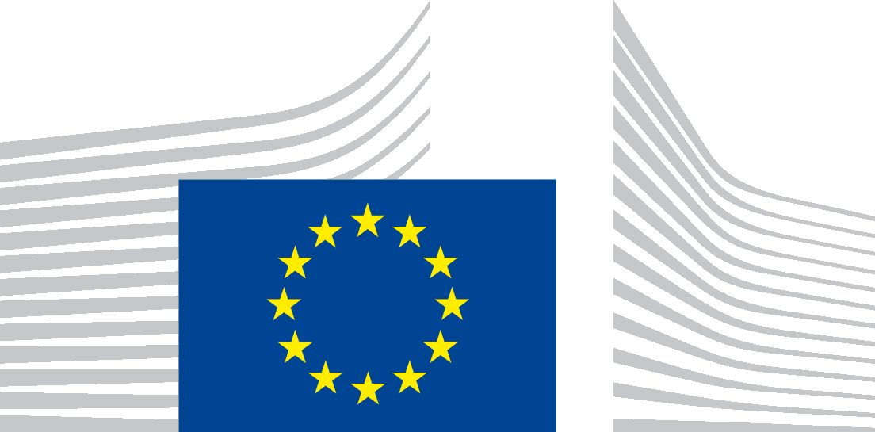 | EUROPEAN COMMISSION  Complaint – Infringement of EU law
Before filling in this form, please read ‘How to submit a complaint to the European Commission’:
https://ec.europa.eu/assets/sg/report-a-breach/complaints_en/
All fields with * are mandatory. Please be concise and if necessary continue on a separate page.

The Commission can receive emails from a ‘certified email service’ (e.g. ...@pec.it), but for technical reasons we cannot send replies to a certified email address. You should therefore provide a standard email address and/or postal address in the complaint form, so that we can reply to you.

1. Identity & contact details
 | Complainant* | Your representative (if applicable)
Title Mr/Ms/Mrs
First name*
Surname*
Organisation:
Address*
Town/City *
Postcode*
Country*
Telephone
E-mail
Language*
Should we send correspondence to you or your representative*: | ☐ | ☐

2. How has EU law been infringed?*
Authority or body you are complaining about:
Name*
Address
Town/City
Postcode
EU Country*
Telephone
Mobile
E-mail

2.1 Which national measure(s) do you think are in breach of EU law and why?*

2.2 Which is the EU law in question?
2.3 Describe the problem, providing facts and reasons for your complaint* (max. 7000 characters):

2.4 Does the Country concerned receive (or could it receive in future) EU funding relating to the subject of your complaint?
Yes, please specify below No I don't know

2.5 Does your complaint relate to a breach of the EU Charter of Fundamental Rights?
The Commission can only investigate such cases if the breach is due to national implementation of EU law.
Yes, please specify below No I don't know

3. Previous action taken to solve the problem*
Have you already taken any action in the Country in question to solve the problem?*
IF YES, was it: Administrative Legal ?

3.1 Please describe: (a) the body/authority/court that was involved and the type of decision that resulted; (b) any other action you are aware of.

3.2 Was your complaint settled by the body/authority/court or is it still pending? If pending, when can a decision be expected?*

IF NOT please specify below as appropriate
Another case on the same issue is pending before a national or EU Court
No remedy is available for the problem
A remedy exists, but is too costly
Time limit for action has expired
No legal standing (not legally entitled to bring an action before the Court) please indicate why:
No legal aid/no lawyer
I do not know which remedies are available for the problem
Other – specify

4. If you have already contacted any of the EU institutions dealing with problems of this type, please give the reference for your file/correspondence:
Petition to the European Parliament – Ref:…………………………………..
European Commission – Ref:………………………………………..
European Ombudsman – Ref:……………………………………………..
Other – name the institution or body you contacted and the reference for your complaint (e.g. SOLVIT, FIN-Net, European Consumer Centres)
5. List any supporting documents/evidence which you could – if requested – send to the Commission.
Don’t enclose any documents at this stage.
6. Personal data*
Do you authorise the Commission to disclose your identity in its contacts with the authorities you are lodging a complaint against?
Yes No
In some cases, disclosing your identity may make it easier for us to deal with your complaint.

